Assignment 4 – Cluster Analysis, Text Mining and Artificial Neural Networking
Part 1 – Cluster Analysis
After doing the necessary preprocessing on the “imdb” dataset such as; removing rows with missing values and duplicates, dropping columns which would not help the machine learn, converting categorical attributes to numerical and scaling the dataset, we used KMEANs and Hierarchical clustering to cluster the related data.
Firstly, we used KMEANS using the elbow method to cluster the related fields of data. For that, we needed an optimum value of k. After running from 1-15, we found that k was best for 3 or 4 (we chose 4).
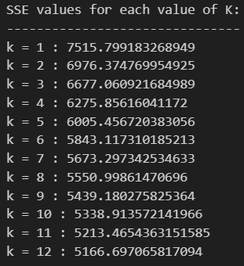
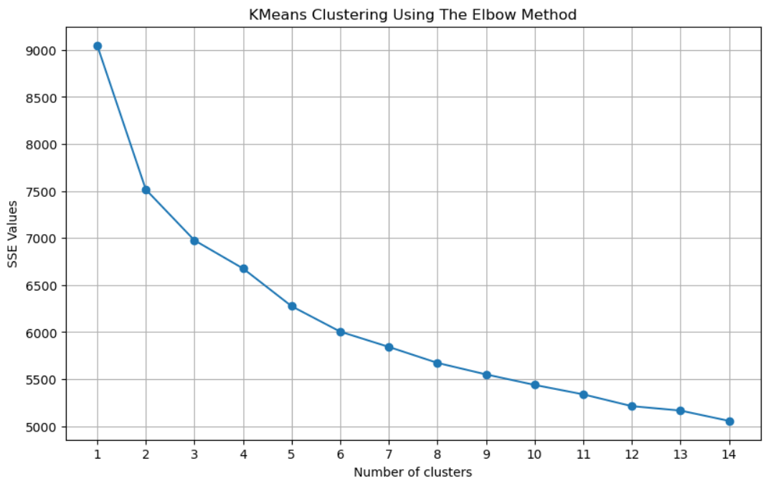
We found this by interpreting the graph above. If we look closely, we can see a “knee” or an “elbow” around when k = 3-4. This is when the clusters are stable and not showing a massive increase or decrease in their SSE value. Using it as the optimum value for k, we got the cluster data for each row as something as below:
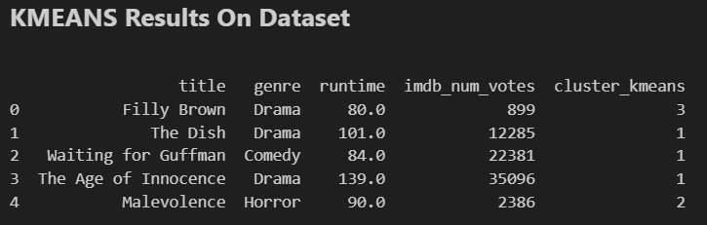
For the Hierarchical clustering, we used dendrograms to view the clusters. The single linkage dendrogram gave the “nearest neighbor” distance which was the minimum distance between any pair of points. The problem with this type is that it cannot show any clear separation of clusters as below:
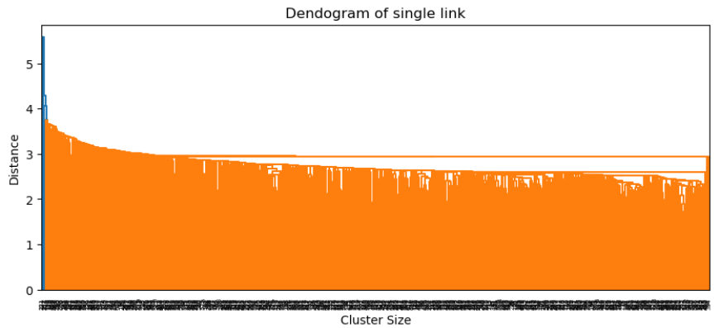
It is difficult to see any real clusters as they are so clumped together.
A complete linkage is the furthest neighbor where the distance is the maximum one between any pair of points. The problem with this type is that it can further break down larger clusters into sub-clusters which compress the data even more.
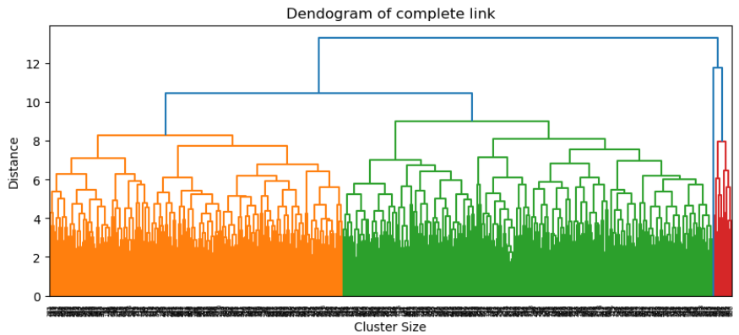
We are, however, able to see some clear merge at distances 8, 10.5-11 and 13-14. These were able to cluster the data into noticeable orange, green and red zones which is certainly far better than the Single linkage we saw above.
Finally, the average linkage is where we got to see the most cluster separation. This used average distance between all pairs of points which were able to produce balanced clusters. We were able to get a total of 5 clusters where we can see some jumps around distance 5 and 6.5.
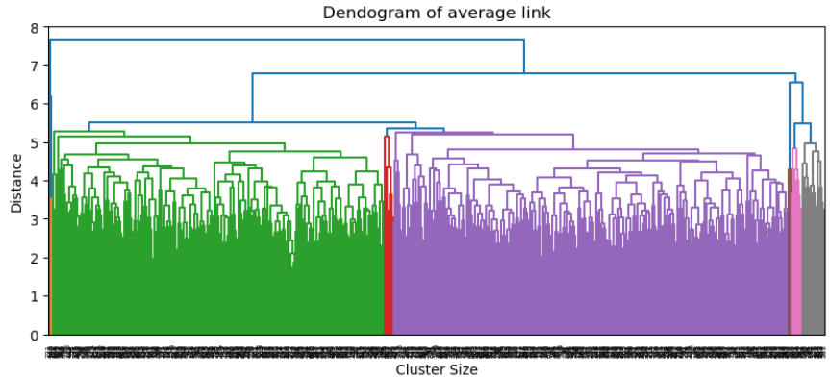

Part 2 – Text Mining
We used count vector and tfidf to mine the text given in “Assignment 4.pdf” which was:
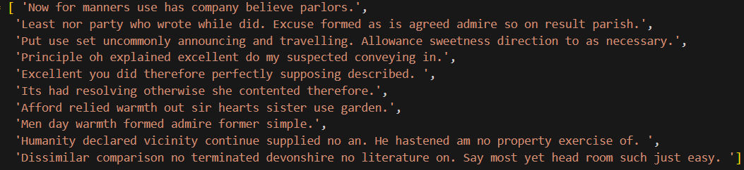
The count vector simply tallies each count of a term from the whole document. It therefore cannot distinguish between distinct and commonly occurring words in the English language such as connecting words. We see in the bar graph we have generated below:
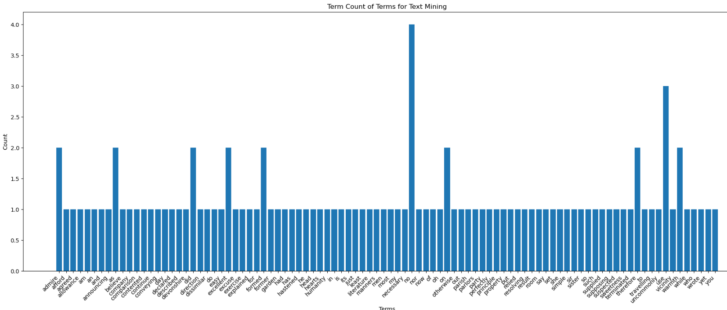
In our case, “no” had a raw count of 4 which was the most frequent occurring term in the whole text. Then, it was “use” with a raw count of 3. Then, “admire”, “as”, “did”, “excellent”, “formed”, “on”, “therefore” and “warmth” all appeared twice while the rest appeared only once. As we can see that the count vector did not treat these common words which appeared twice as distinct and simply just counted them the number of times they appeared in each line. This may not be ideal for our model as you have to have some words which would almost always appear in the language for it to make sense such as; “and” or “the”. Sadly, the count vector cannot understand this. It does allow us to see the most frequent occurring word, though.

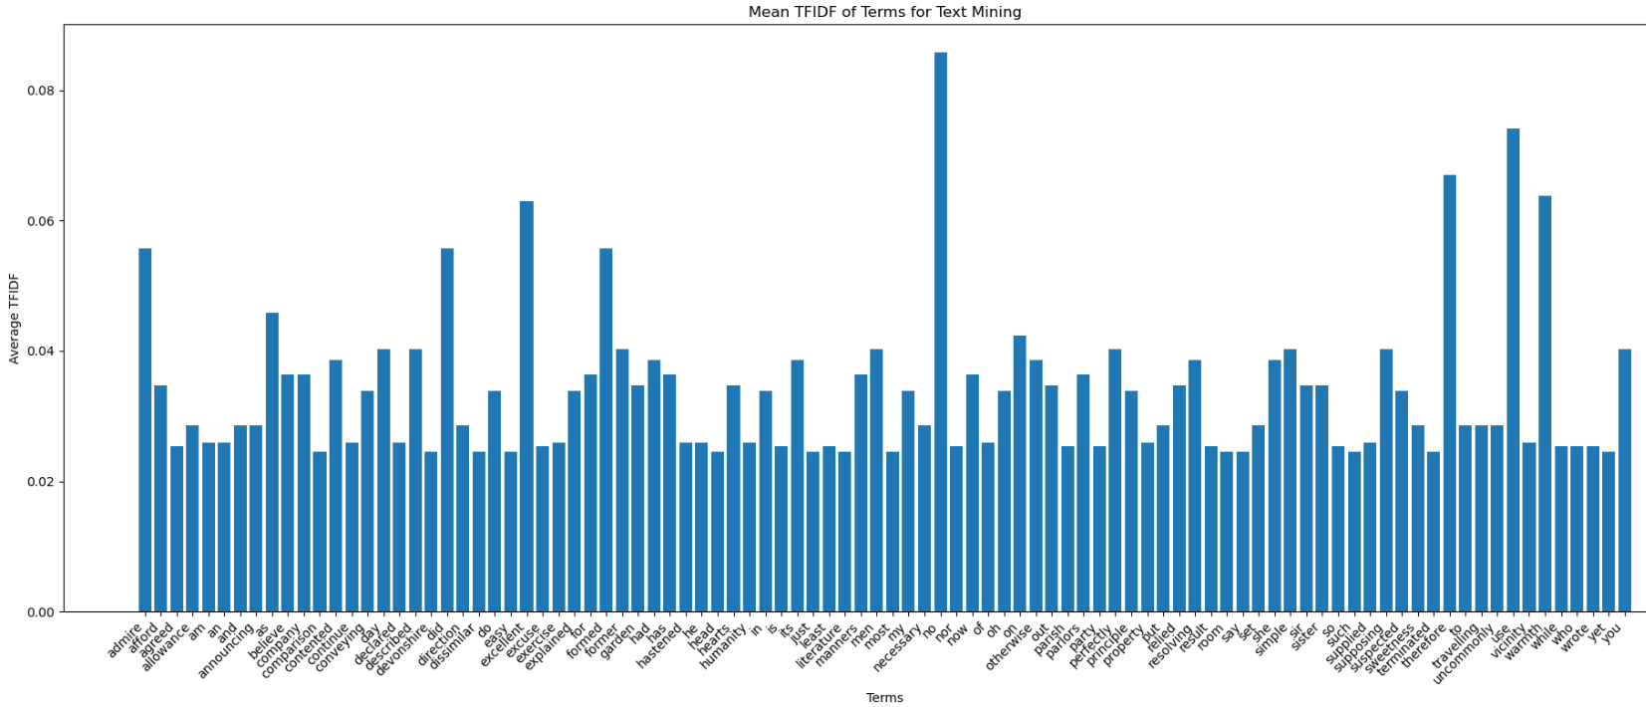
On the other hand, the TFIDF method does take into account the weight of these common words in the overall appearance of the entire text. Although these same words do appear again as the most frequent as in the previous case, we take note of the mean weight of them now. For example, instead of just appearing 4 times in the whole text, “no” has a mean value of about 0.099852 which I had calculated by this simple formula:
(number of times “no” appeared in that line)
-------------------------------------------------------- * log(10 / number of lines with “no”)
total length of that line)

which gave me; (2/14) *log (10/2) = 0.099852, which also confirms with our graph.
The farther away the value from 0, the more distinct it is and the closer, the more common it is. This allowed me to see that “no” was not a common word but a rather distinct one in this text.
Part 3 – Artificial Neural Network (ANN)

